# 一 add ssh public key to github

## 生成key

1. 采用ssh-keygan命令生成.
2. 最后需要对应的(github的)邮箱.
3. 然后一路默认就可以(一路回车)

|  |
| --- |
| $ **ssh-keygen -t rsa -C kawayi_rendroid@163.com**  Generating public/private rsa key pair.  Enter file in which to save the key (/c/Users/raytine/.ssh/id_rsa):  Enter passphrase (empty for no passphrase):  Enter same passphrase again:  Your identification has been saved in /c/Users/raytine/.ssh/id_rsa.  Your public key has been saved in /c/Users/raytine/.ssh/id_rsa.pub.  The key fingerprint is:  SHA256:t3Lvk4RQUlrVzG1+hVeOdcBD8vnnie69fYlU+iRIt+U kawayi_rendroid@163.com  The key's randomart image is:  +---[RSA 2048]----+  | .o.o*o+=|  | .o. oB=*|  | .o +=o|  | . . . +o|  | S.o.o * +|  | ..o.=.Eo|  | . o..o=.o|  | o .+..oo|  | .++ o+|  +----[SHA256]-----+ |

## 将pubkey添加到github上.

1. 在右上角个人页中选择setting.

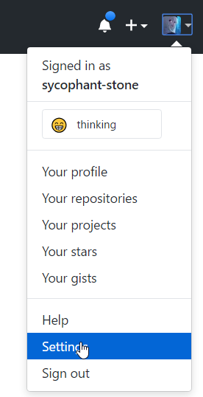

1. 然后在ssh中添加key

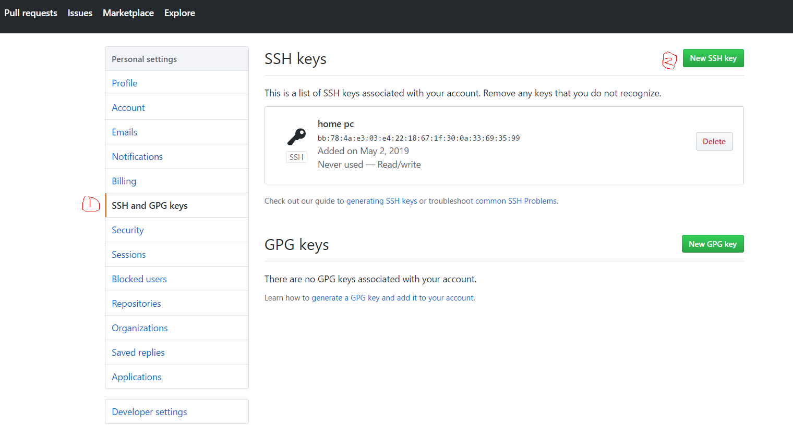

## 配置工程

1. 有两种github的代码下载方式, 一种是https的, 这个每次push的时候都需要输入账户名和密码.
2. 还有一种是利用git的方式.

|  |
| --- |
| $ git remote -v  origin **https**://github.com/sycophant-stone/alg_introduction.git (fetch)  origin https://github.com/sycophant-stone/alg_introduction.git (push) |

修改如下:

|  |
| --- |
| git remote set-url origin git@github.com:sycophant-stone/alg_introduction.git |

## 使用public key

1. 添加本地的id_rsa
2. 不要添加本地的id_rsa.pub.
3. Id_rsa.pub是给github上保存的.

|  |
| --- |
| ssh-add.exe /c/Users/raytine/.ssh/id_rsa |